

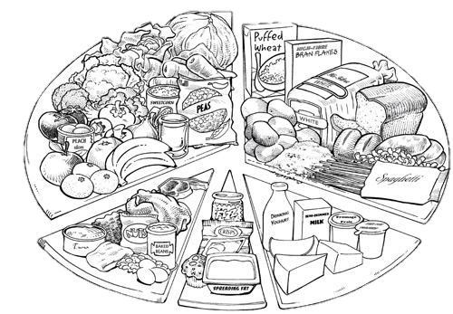

**Year 8**

**Food Science and Technology**

‘A Healthy Lifestyle begins with Breakfast’

|  |  |
| --- | --- |
| **Name:** | **Teacher:** |
| **Lesson 1:**  **Day: Period:** | **Lesson 2:**  **Day: Period:** |
| **Special Dietary Requirements:** | |

**FOOD & NUTRITION POLICY**

Home Economics is a practical subject that aims to help people to improve their everyday living by being more independent and able to make informed decisions.

It brings together aspects of English, Maths, Science, Society and the Environment and the Arts. Home Economics shows you how you can apply them to living and working in today’s society.

General:

1. Students are required to be lined up outside the classroom, **ON TIME.**
2. Students who are **absent** are expected to **catch up** on missed work.
3. Students are required to bring writing equipment to **ALL** lessons.
4. **SHOES:** Closed-in shoes must be worn for all lessons.
5. Show **RESPECT** by entering the classroom quietly and awaiting further instructions.
6. **STUDENT WORKBOOKS MUST REMAIN IN CLASS.**

Homework/Assignment work:

1. Most work will be completed in class if time is used wisely. If not completed in class, it will need to be finished in your own time.
2. Each assignment must be completed by set date. Failure to complete assignments and written work will result in loss of marks, and may result in a lower grade than you are capable of achieving.
3. If you are absent on the day an assignment is given out, **you still have to do it**. See the teacher for an extra extension of time with a note from home.

Cooking Classes:

1. Students are required to bring **a plastic container** with a lid to practical classes.
2. Under no circumstances is equipment of any type to be taken from the room.
3. **Hair:** For reasons of good hygiene students with shoulder length hair must have it tied back properly. (This includes long fringes that hang half way down the face)
4. You are required to follow hygiene rules when preparing food. Ensure you clean up properly otherwise you will lose marks and may be required to spend your lunchtime cleaning.
5. Students are required to sit at a table with a suitable plate whenever they are eating. They will also be required to wipe that table down with a sponge when they are finished eating.

I have read the Lower School Home Economics Policy and will meet its requirements.

Name: _____________________________ Date: ___________________

Signed: _____________________________

**HOME ECONOMICS QUESTIONNAIRE**

Name ______________________________________________

Write 3 things about yourself so I can get to know you better

___________________________________________________________________________

___________________________________________________________________________

___________________________________________________________________________

What is your favourite food? __________________________________________________

What is your least favourite food? ______________________________________________

What is your favourite thing to cook? ___________________________________________

Get to know you Bingo

Use the following bingo squares to get to know your peers. Walk around the room asking individuals the questions in each of the squares. If they answer yes to any of the questions, place a cross through that square. You may only ask an individual one question and then move on to another peer. Once your bingo sheet is full, shout “BINGO!” and take a seat.

|  |  |  |  |
| --- | --- | --- | --- |
| Do you eat breakfast every day? | Do you help to wash up at home? | Do you regularly get take away food? | Do you like pineapple on your pizza? |
| Do you cook regularly at home? | Have you cooked at school before? | Do you make your own lunch to bring to school? | Do you know how to use a microwave? |
| Do you like sweet foods? | Do you bring your lunch to school every day? | Do you bring your own water bottle to school? | Do you help with the food shopping? |
| Do you like savoury foods? | Did you eat breakfast this morning? | Have you ever eaten chocolate? | Do you like eggs? |

**KITCHEN HYGIENE**

- Clean work surfaces **before** and **after** use.

- Sweep up crumbs and mop up spilt food **quickly**.

- We prepare food on a work surface in a kitchen – **don’t sit there.**

- Food should be covered at all times to prevent it from drying out and to prevent insects from sitting on it.

- All food in the refrigerator should be covered.

- Flies, rats and mice pass harmful bacteria unto food, keep them away from food.

- Waste bins should be emptied at the end of every day or as soon as they are full. Wash them out regularly.

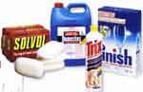- Large waste bins should be stored away from the kitchen, and should have a tight fitting lid.

- Cloths should be washed frequently.

GOLDEN RULE: **CLEAN AS YOU GO!!!!**

**PERSONAL HYGIENE**

- Don’t touch your nose when working with food.

- Don’t lick your fingers during cooking – taste food with a clean spoon.

- Don’t cough or sneeze near food.

- Cover all cuts and sores with a waterproof band aid.

- Always wash your hands after visiting the toilet.

- Wash your hands before handling food.

- Cover your clothes with a clean apron.

**10 GOLDEN RULES FOR SAFE FOOD PREPARATION**

1. Wash ___________ before starting to prepare _________ and after touching bacteria breeding areas (toilet, garbage, soil, raw meat, tissues).
2. Make sure all equipment, benches, sinks and floors are _______.
3. Wear ___________ to protect clothing.
4. Tie back _____________ hair.
5. Keep f________ and e________ protected from insects.
6. _________ any sores or wounds.
7. Keep foods that go bad easily (i.e. perishables) in the _______.
8. Do not prepare food for __________ if you are not well.
9. Do not lick your _______ while preparing food.
10. Do not replace the tasting spoon in food after _________.

|  |
| --- |
| Other safety and hygiene issues: |
|  |
|  |
|  |
|  |
|  |
|  |
|  |
|  |
|  |
|  |
|  |
|  |
|  |
|  |
|  |
|  |

**SPOT THE SAFETY HAZARDS**

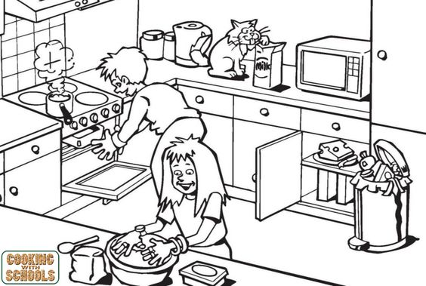Circle and list the hazards you see in this picture. When you have finished get together with your group members and compare the answers you all have. Did you miss anything?

|  |
| --- |
|  |
|  |
|  |
|  |
|  |
|  |
|  |
|  |
|  |
|  |
|  |

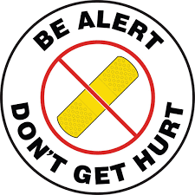**SAFETY IN THE KITCHEN**

Accidents in a kitchen are often caused by:

* Being in a hurry
* Having poor work habits
* Carelessness

Using the words in the box, fill in the spaces to complete each sentence:

|  |  |  |  |  |  |
| --- | --- | --- | --- | --- | --- |
| Cord | Wet | Fire Blanket | Hot | Mop | Switch |
| Spills | Hot | Cold | Downwards | Knives | Sink |
| Towards | Bin | Handle | Soapy | Inwards | Body |
| Tea Towels | Frayed | Run | Wet | Doors |  |

1. When passing a knife to another person, offer them the ________________
2. When carrying a knife around the room, hold it close to the ___________ with the blade pointing _____________
3. When chopping, slicing and dicing, make sure ___________ are sharp so that they will cut efficiently
4. Do not cut ____________ yourself
5. When washing up, place __________ water in the sink, before adding ____________ water.
6. Clean up _______________ immediately
7. Use a __________ to clean up spills from the floor.
8. When washing dishes use hot, ____________ water.
9. Do not put scraps down the ____________. Place scraps in the ___________.
10. Place saucepan handles _____________ on the stove so that they can’t be bumped by someone walking past.
11. When cooking with fat or oil, do not allow it to become too _____ .
12. Do not throw ______________ on a fat fire, smother it with a ______________.
13. If using electricity, turn ___________ off after use. Pull the plug out by holding the plug and not yanking the ___________.
14. Keep cupboard ____________ closed after use.
15. Do not ___________ in the room, especially when carrying something.
16. When removing hot foods from the oven, do not use ___________ oven cloths as steam burns may be worse than dry burns.

Don’t forget to sweep the floor!

**KITCHEN RULES**

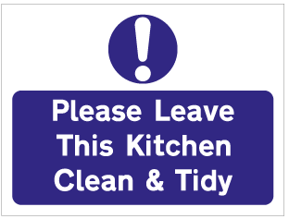

**It is your responsibility to complete the following tasks before the conclusion of each lesson**

1. Make sure you are packed up 5 minutes before the end of the lesson
2. Leave washed and dried dishes on the bench to be checked by the teacher
3. Return all utensils/equipment to the correct drawer/cupboard

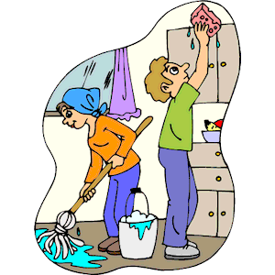

1. Wipe the stove top
2. Rinse dish cloth and hang over tap
3. Clean and dry the sink
4. Clean and dry the bench
5. Placed used tea towels in blue laundry basket
6. Wipe down apron and place back on hook

Return your book back to your class box

**WHAT HYGIENIC PRACTICES ARE IMPORTANT?**

It is essential that hygienic habits are observed when cooking with food. Complete these hygiene rules by filling in the spaces.

1. ____________________ must be thoroughly washed before handling food. _________________ should be clean.
2. Keep __________________ neatly in place and avoid handling it. Long __________________ should be tied back.
3. All clothes must be clean. Wear a _________________ apron or pinafore to protect outer clothing.
4. Always cover mouth or nose if you _______________ or ________________; wash your hands immediately afterwards.
5. Cover ________________ and ________________ with sterile, waterproof dressing.
6. Use a ________________ for tasting food. Do not put a ______________ that has been in your mouth back into the food.
7. All utensils and work areas should be thoroughly ________________.
8. When possible, use a ________________ or ___________________ to avoid hands coming into contact with food.
9. Wash hands, boards and knives after using them to cut fresh ____________, e.g. ___________________ or _____________________.
10. Do not used chipped ____________________ or __________________ ware.
11. Wash dishcloths and _____________________ often, so that only clean ones are used.
12. Always _________________ food from dust and flies with a clean throw-over or tea towel.
13. Check the ________________ date on packages before buying.
14. After shopping, place perishable foods in the ____________________ as soon as you get home.
15. __________________ and ____________________ should always be washed before using.
16. Never refreeze _____________________ food.

**Word Bank**

|  |  |  |  |  |  |
| --- | --- | --- | --- | --- | --- |
| apron | cuts | glass | meat | tea-towel | vegetables |
| china | defrosted | glove | protect | tongs |  |
| clean | food | hair | sneeze | use-by |  |
| clean | fridge | hair | sores | utensil |  |
| cough | fruit | hands | spoon | vegetables |  |

**TREASURE HUNT**

**Look in cupboards, drawers and around the room to find the answers!**

* + - 1. Drawers and cupboards should be kept closed because ______________________________ into them.
      2. Two things you should not do to power points are touch them with ______________________ and ________________________ then ______________________ for no reason.
      3. When you need to hold or move something hot, always use a _________________________ and not a ____________________________.
      4. We use an ________________________________________ to collect ingredients when we are cooking and they are found in the ________________________.
      5. If you sneeze or cough, always ________________________________________________________. Wash your __________________ afterwards too.
      6. Always _________________ your ______________________ before you cook and use a ____________________ if you need to taste your cooking.
      7. Handles of saucepans and pots should be turned __________________________________ the _______________________ of the stove.
      8. Spillages and breakages must be ______________________________________________________.
      9. Which ovens are fan forced? _______________________________________________

What are the differences between fan forces and non-fan forced ovens? _______________________ __________________________________________________________________________________

* + - 1. Where are the brooms kept?
      2. What do you wash up in?
      3. What has to be completed by everyone at the end of a cooking lesson, after the dishes are finished?

___________________________________________________________________________________

* + - 1. 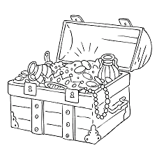How can you tell the difference between benches? __________________________________________

**EQUAL MEASURES**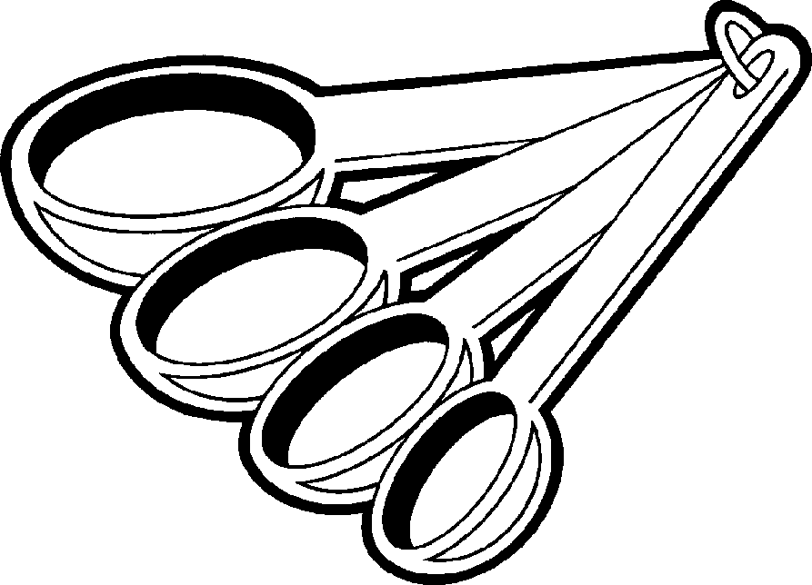

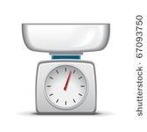The following table is using a liquid measure (millilitres) to measure a dry ingredient, (Flour) – there are different conversion tables for individual dry ingredients.

|  |  |  |
| --- | --- | --- |
| **Spoons/Cups** | **Mls** | **Grams** |
| 1 teaspoon (1t) | 5 mls | 2.5 g |
| 1 Tablespoon (1T) | 20 mls | 10 g |
| ¼ Cup | 62.5 mls | 30 g |
| ½ Cup | 125 mls | 60 g |
| 1 Cup | 250 mls | 125 g |

1. The recipe asks you to measure ¼ Cup of milk. Haw many mls is that? _____________
2. You need 250 g of flour. How many cups do you need? ______________
3. How many teaspoons make a tablespoon? _________________
4. The recipe has asked for 2 teaspoons (2t) of flour. How many g? _______________
5. You need 500 mls of orange juice. This is _____________ cups.
6. How many mls in a litre? ______________.
7. How many Tablespoons make up ½ Cup of flour? ___________
8. If you had 125 g of flour, how many Tablespoons would you use? ________________
9. One half Kilogram of flour is equal to _______________cups.
10. 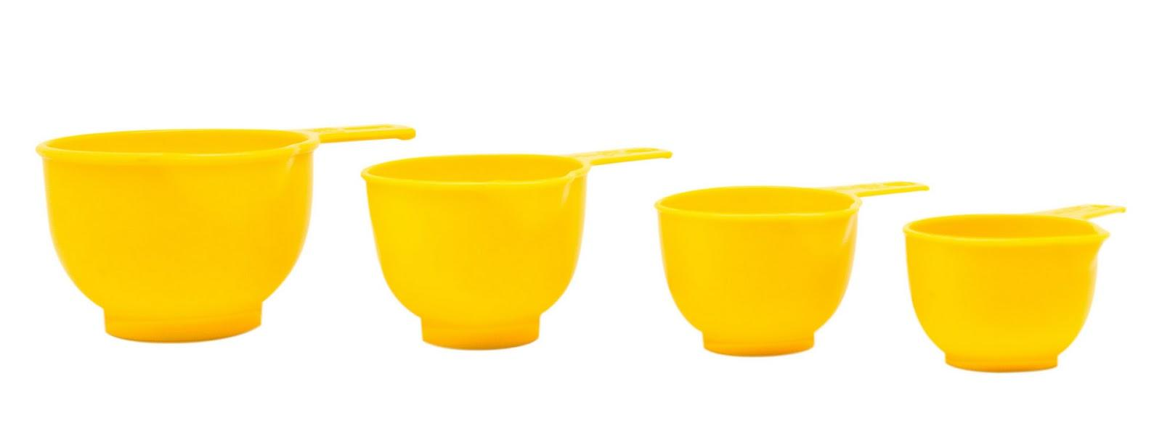How many mls of water would you be using if you filled 1½ cups? ________________
11. How can you collect ¾ C of flour? ____________________________

**Facts and Figures**

Successful food preparation and cookery will depend on your ability to accurately measure the ingredients you need to complete a recipe. The key to accurate measuring is to use the correct equipment!

Next to each of the following abbreviations write what it stands for.

C = __________________________

T = __________________________

Kg = __________________________

L = __________________________

g = __________________________

ml = __________________________

t = ________________________

Descriptive Words

|  |  |  |  |  |  |  |  |  |  |  |  |  |  |  |  |  |  |
| --- | --- | --- | --- | --- | --- | --- | --- | --- | --- | --- | --- | --- | --- | --- | --- | --- | --- |
| **Y** | **A** | **I** | **D** | **P** | **D** | **Y** | **O** | **D** | **T** | **T** | **X** | **G** | **B** | **R** |  | APPEALING | MOIST |
| **M** | **I** | **U** | **R** | **E** | **G** | **C** | **S** | **P** | **R** | **I** | **Y** | **N** | **I** | **E** |  | BITTER | MUSHY |
| **I** | **L** | **A** | **Z** | **N** | **L** | **T** | **R** | **A** | **A** | **Y** | **P** | **I** | **T** | **D** |  | BLAND | OPAQUE |
| **L** | **H** | **A** | **I** | **H** | **R** | **U** | **N** | **E** | **T** | **Q** | **M** | **L** | **T** | **N** |  | BRIGHT | RAW |
| **S** | **L** | **R** | **M** | **O** | **W** | **S** | **F** | **R** | **A** | **F** | **U** | **A** | **E** | **E** |  | BURNY | ROUGH |
| **G** | **T** | **D** | **N** | **A** | **L** | **B** | **W** | **R** | **U** | **M** | **L** | **E** | **R** | **T** |  | CLEAR | SALTY |
| **S** | **M** | **G** | **R** | **U** | **T** | **A** | **L** | **F** | **U** | **B** | **Y** | **P** | **A** | **Y** |  | COLOURFUL | SHARP |
| **Y** | **X** | **I** | **C** | **H** | **T** | **O** | **O** | **M** | **S** | **O** | **Y** | **P** | **E** | **L** |  | COMPRESSED | SLIMY |
| **Q** | **N** | **E** | **L** | **E** | **E** | **F** | **A** | **T** | **T** | **Y** | **L** | **A** | **L** | **B** |  | CREAMY | SMOOTH |
| **W** | **N** | **I** | **R** | **D** | **E** | **S** | **S** | **E** | **R** | **P** | **M** | **O** | **C** | **R** |  | CRISP | SOFT |
| **T** | **Y** | **Y** | **A** | **U** | **W** | **P** | **D** | **T** | **Y** | **M** | **S** | **Y** | **C** | **I** |  | CRUNCHY | SOUR |
| **H** | **G** | **U** | **O** | **R** | **S** | **O** | **U** | **R** | **A** | **C** | **O** | **O** | **H** | **G** |  | DRY | SPICY |
| **Y** | **T** | **L** | **A** | **S** | **G** | **O** | **L** | **D** | **E** | **N** | **I** | **I** | **F** | **H** |  | DULL | STIFF |
| **C** | **R** | **U** | **N** | **C** | **H** | **Y** | **H** | **S** | **U** | **M** | **G** | **P** | **S** | **T** |  | FATTY | STRINGY |
| **C** | **R** | **I** | **S** | **P** | **F** | **F** | **I** | **T** | **S** | **H** | **V** | **Y** | **S** | **T** |  | FLAT | STRONG |
|  | | | | | | | | | | | | | | |  | GLAZED | SWEET |
|  | | | | | | | |  | | | | | | |  | GOLDEN | TANGY |
|  | GRAINY | TART |
|  | HIGH | TENDER |
|  | LUMPY | TRANSLUCENT |
|  | MILD | WATERY |

Descriptive language is useful when trying to describe food to others. Descriptive words can be categorised into senses to help with our evaluations. Can you organise these words into senses?

**NEW TASTE SENSATIONS…**

When cooking, it is important to taste new and interesting foods. Today you will be tasting and describing some different foods. For each food you need to describe:

**APPEARANCE: clear, bright, dull, colourful, rough**

**TASTE: sweet, sour, bitter, tangy, bland, salty, grainy**

**TEXTURE: soft, crunchy, smooth, dry, tough, hard**

**SMELL: strong, sweet, spicy, fruity, sour, acrid**

Using the appropriate equipment (tongs, enamel plate, measuring equipment) collect nine (9) different foods to explore. Remember you must be descriptive in your evaluation. Write down your evaluation as you try new food.

|  |  |  |  |  |
| --- | --- | --- | --- | --- |
| **FOOD** | **TASTE** | **APPEARANCE** | **TEXTURE** | **SMELL** |
|  |  |  |  |  |
|  |  |  |  |  |
|  |  |  |  |  |
|  |  |  |  |  |
|  |  |  |  |  |
|  |  |  |  |  |
|  |  |  |  |  |
|  |  |  |  |  |
|  |  |  |  |  |

**CLEANING UP AFTER THE FUN**

Whilst you enjoy the cooking, there is always that mess left behind. It is YOUR responsibility to keep your area clean and tidy.

Whilst waiting for the food to cook, use the time to wash the dishes and wipe down the benches. Then, when the food is ready to eat, you will be able to relax and enjoy eating without having to think of dishes left in the sink.

These are many ways to go about washing and drying dishes. This is the way that we find works best in the centre.

Complete the sentences using the following words:

|  |  |  |  |
| --- | --- | --- | --- |
| dry | stack | rinse | scrape |
| wash | fill | detergent | checked |

* + - 1. ________________ solid scraps into the bin.
      2. ________________ dishes thoroughly.
      3. ________________ in order of washing up. You should wash the glassware and plastic first, then the cutlery, followed by china, then the cooking dishes and lastly the pots, pans and meat dishes.
      4. Half ________________ the sink with hot water and a squirt of ________________.
      5. ________________ the dishes carefully.
      6. Leave your dishes out to be ________________ by the teacher.

Do not forget to sweep the floor!

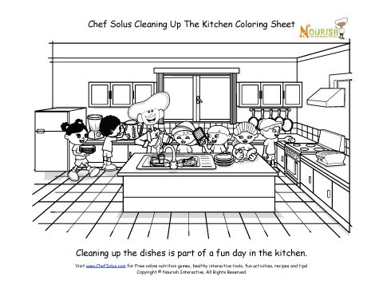

**USE AND CARE OF THE STOVE**

**How do you turn an electric stove on in the kitchen?**

|  |
| --- |
|  |
|  |
|  |
|  |

**How do you turn a gas stove on in the kitchen?**

|  |
| --- |
|  |
|  |
|  |
|  |

**Use the words below to complete the safety instructions. Make sure you cross off the words as you go.**

|  |  |  |  |
| --- | --- | --- | --- |
| **inwards** | **door** | **food** | **preheat** |
| **preheat** | **racks** | **door** | **oven mitts** |
| **open** | **oven mitts** | **recipe** | **match** |
| **stove tops** | **spills** | **size** |  |

|  |  |
| --- | --- |
|  | **Stove Top**   * **Do not put cloths, aprons, files or** ______________ on ______________. * **Wipe up** ______________ before they burn. * **Have pan/pot handles facing** ______________ the pan/pot to the ______________ of the element. |
| **The Grill**   * ______________ before use. * Leave ______________ open when in use. * Check ______________ before grilling regular. |
| **The Oven**   * ______________before use. * Arrange ______________ before heating. * Pull ______________ right down when putting items in or out of the oven.   (DON’T SLAM THE OVEN DOOR)   * Do not leave door ______________to long. * Use oven______________ if available. * Use ______________ for cooking as a guide. |

**NUTRITION**

Healthy Eating Pyramid

|  |  |  |  |  |  |  |
| --- | --- | --- | --- | --- | --- | --- |
| **Adolescents** | **Vegetables and legumes** | **Fruit** | **Grains (cereal)** | **Lean meat, fish, poultry, eggs, nuts, seeds, legumes, beans** | **Milk, yoghurt, cheese & alternatives** | **Allowance for additional serves from any food group\*** |
| **Girls 12-13 years** | **5** | **2** | **5** | **2.5** | **3.5** | **0-2.5** |
| **Girls 14-18 years** | **5** | **2** | **7** | **2.5** | **3.5** | **0-2.5** |
| **Boys 12-13 years** | **5.5** | **2** | **6** | **2.5** | **3.5** | **0-3** |
| **Boys 14-18 years** | **5.5** | **2** | **7** | **2.5** | **3.5** | **0-5** |

**Time Plans**

To make sure you can complete your cooking in a given time, you must carefully plan you menu. Below is an example of a time plan for corn burgers.

**PRODUCE**

Name of Recipe: ____________________________________________________________________

|  |  |  |
| --- | --- | --- |
| **AMOUNT OF TIME** | **WHO** | **PRODUCTION STEPS** |
| 3m | ALL | Wash hands and put apron on |
| 7m | John | Preheat oven |
|  | Anne | Get out equipment to collect: Plate, tongs, butter knife, measuring cups & jug, measuring spoons |
|  | Ben | Collect recipe book |
| 1m | ALL | Read through recipe |
| 5m | John | Collect ingredients |
|  | Anne | Collect equipment specific to recipe |
|  | Ben | Grate cheese |
| 2m | John | Remove centre from rolls and break into small pieces |
| 5m | Anne | Grill hollow bread rolls until golden |
|  | John | Chop onion |
|  | Anne | Add mince and onion to frypan and cook until brown |
| 2m | Ben | Add tomato paste, sweetcorn, water and the centre of bread rolls to mince mixture. Stir well |
| 2m | Ben | Divide filling into three and spoon into bread rolls |
| 2m | John | Top bread rolls with grated cheese |
| 1m | John | Place in oven until cheese is melted and golden |
| 8m | Anne | Wash dishes |
|  | Ben | Dry dishes |
|  | John | Clean surface |
| 1m | ALL | Get teacher to inspect dishes |
| 3m | John | Put away dishes, tidy drawers and cupboards |
|  | Anne | Serve up and eat |
| 5m | John | Wash up eating equipment |
|  | Anne | complete duties |
|  | Ben | Dry and put away |
| 1m | ALL | Get teacher to inspect cupboards |
|  | ALL | Bell – go to next class |

**SUGAR**

Too much sugar in food or drink can make it high in kilojoules, or ‘energy dense’. This can make it harder to control your weight. It has also been linked with tooth decay. Not all sugars are the same. There are:

Naturally occurring sugars

These are found in milk, fruit, vegetables and legumes. They are eaten in smaller quantities, along with many important nutrients.

Added sugars

These have been refined from plants such as sugar cane. They can be added to food or drink in large amounts to make cakes, biscuits and soft drinks. Added sugars may not come with helpful nutrients and can increase the energy of a food or drink. So they are sometimes called ‘energy dense’ and ‘nutrient poor’.

Sometimes people think that eating too much sugar leads to diabetes, because diabetes is a condition where blood glucose (or blood ‘sugar’) needs to be managed. Sugar itself does not lead to diabetes. However, being overweight increases a person’s risk of type 2 diabetes and too much added sugars can cause weight gain.

*Source:* [*Dietitians Association of Australia*](http://daa.asn.au/for-the-public/smart-eating-for-you/nutrition-a-z/sugars/)*.*

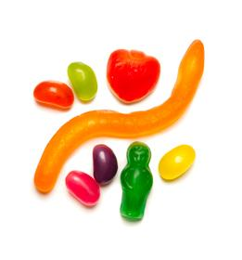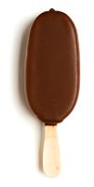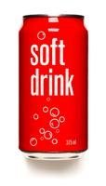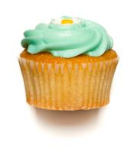

**DRINKS**

**DIET SOFT DRINKS, ICED TEA, FRUIT JUICES, SMOOTHIES, FLAVOURED WATER – THE CHOICES SEEM ENDLESS! EACH YEAR, MORE DRINKS COME ONTO THE MARKET AND A GREATER AMOUNT OF OUR TOTAL ENERGY (OR KILOJOULE) INTAKE NOW COMES FROM DRINKS.**

**So what should we be drinking, and how much?**

The human body is made up of 50-75% water. Staying well-hydrated (especially in hot weather and when exercising) is crucial to making sure our bodies function at their best. The following is a good guide of how much to aim for:

* 1.5– 2L/day for adults, and
* 1 – 1.5L/day for children

**What is the best drink?**

While all fluids can count towards your daily fluid intake, the Australian Guide to Healthy Eating recommends **WATER** as the best drink. It contains no kilojoules and is the best fluid for hydrating the body.

**Milk**

The Australian Guide to Healthy Eating also recommends milk, particularly low-fat varieties for adults, as part of a healthy diet. Milk has important nutrients, like [protein](http://daa.asn.au/?page_id=862) and [calcium](http://daa.asn.au/?page_id=772), and is about 90% water.

If you are buying flavoured milk, compare brands and select those that are lower in [saturated fat](http://daa.asn.au/?page_id=865) and added sugar. Watch the serve sizes of smoothies, which may be ‘super-sized’, and can contain many kilojoules.

**Fruit juice**

Fruit juice can give you valuable nutrients, but most types naturally contain a similar amount of sugar and kilojoules to soft drinks.  Big serve sizes from juice bars such as Boost Juice have become very popular. Fruit juices should be watered down so just to add flavor to the water.

**Sugary soft drinks, fruit drinks and cordials**

These drinks are low in nutrition and can contain plenty of extra kilojoules which you do not need. The Australian Guide to Healthy Eating considers these as ‘extra foods’; in other words, they are not needed in your diet and should be limited.

Diet varieties may be lower in energy and sugar, but remember diet soft drinks can be quite acidic and too much of these drinks may contribute to tooth decay.

(Source: <http://daa.asn.au/for-the-public/smart-eating-for-you/nutrition-a-z/drinks/>)

**HOW TO UNDERSTAND FOOD LABELS**

Labels on most packaged food must meet strict requirements that include information for people with food allergies, food additive listings and food storage instructions.

The Nutrition Information Panel on a food label offers the simplest and easiest way to choose foods with less saturated fat, salt (sodium), added sugars and kilojoules, and more fibre. It can also be used to decide how large one [serve](https://www.eatforhealth.gov.au/food-essentials/how-much-do-we-need-each-day/what-serve) of a food group choice or [discretionary food](https://www.eatforhealth.gov.au/food-essentials/discretionary-food-and-drink-choices) would be and whether it’s worth the kilojoules.

**What to look for….**

Don’t rely on health claims on labels as your guide. Instead learn a few simple label reading tips to choose healthy foods and drinks, for yourself. You can also use the label to help you lose weight by limiting foods that are high in energy per serve.

(Source: https://www.eatforhealth.gov.au/eating-well/how-understand-food-labels)

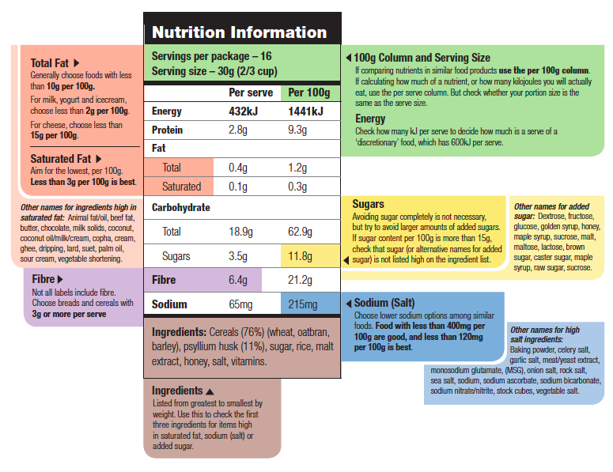

**CARBOHYDRATES**

**CARBOHYDRATES ARE AN IMPORTANT NUTRIENT FOUND IN MANY FOODS. CARBOHYDRATE CONTAINING FOODS INCLUDE BREADS, BREAKFAST CEREAL, RICE, PASTA, NOODLES, FRUIT, POTATO AND STARCHY VEGETABLES, CORN, DRIED BEANS AND LENTILS, SUGAR, MILK AND YOGHURT.**

Carbohydrate is an important source of energy for the body. Many carbohydrate-containing foods are high in [dietary fibre](http://daa.asn.au/?page_id=800) and are healthy food choices. Try to eat carbohydrate-containing foods in every meal to provide the body with energy throughout the day.

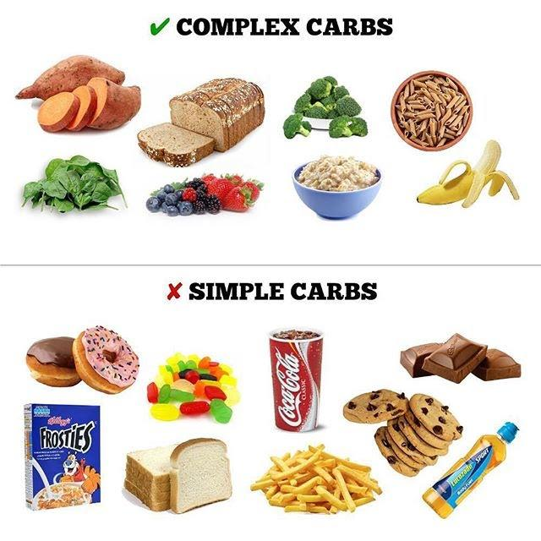

**PROTEIN**

**PROTEIN IS AN IMPORTANT NUTRIENT NEEDED FOR THE GROWTH AND REPAIR OF CELLS. SOURCES INCLUDE: MEAT. CHICKEN, FISH, EGGS, NUTS AND SEEDS, DRIED BEANS AND LENTILS, DAIRY PRODUCTS AND SOY PRODUCTS**

Protein can also be used for energy, especially if inadequate [carbohydrate](http://daa.asn.au/?page_id=774) foods are eaten. Protein needs are increased during times of cell growth and repair such as:

* During childhood and adolescence
* Pregnancy and lactation
* After illness or surgery.

Protein can come from animal or plant foods such as:

* Meat, chicken, fish
* Eggs
* Nuts and seeds
* Dried beans and lentils
* Dairy products such as milk, yoghurt and cheese
* Soy products

It is best to choose those protein-rich foods that are lower in [saturated fat](http://daa.asn.au/?page_id=865).

(Source: <http://daa.asn.au/?page_id=862>)

**FAT**

**FAT ARE AN ESSENTIAL PART OF OUR DIET AND IS IMPORTANT FOR GOOD HEALTH. THERE ARE DIFFERENT TYPES OF FATS, WITH SOME FATS BEING HEALTHIER THAN OTHERS. TO HELP MAKE SURE YOU STAY HEALTHY, IT IS IMPORTANT TO EAT UNSATURATED FATS IN SMALL AMOUNTS AS PART OF A BALANCED DIET. WHEN EATEN IN LARGE AMOUNTS, ALL FATS, INCLUDING HEALTHY FATS, CAN CONTRIBUTE TO WEIGHT GAIN. FAT IS HIGHER IN ENERGY (KILOJOULES) THAN ANY OTHER NUTRIENT AND SO EATING LESS FAT OVERALL IS LIKELY TO HELP WITH WEIGHT LOSS. A DIET THAT IS LOW IN SATURATED FATS AND TRANS FATS, BUT THAT ALSO INCLUDES MODERATE AMOUNTS OF UNSATURATED FATS WILL HELP YOU STAY HEALTHY.**

**Saturated fats**

Eating greater amounts of saturated fat is linked with an increased risk of heart disease and high blood cholesterol levels. These fats are usually solid at room temperature and are found in:

**Animal-based products:**

Dairy foods – such as butter, cream, full fat milk and cheese

* Meat – such as fatty cuts of beef, pork and lamb and chicken (especially chicken skin), processed meats like salami, Some plant-derived products:
* Palm oil, ccoconut, coconut milk and cream

**Many manufactured and packaged foods:**

* Fatty snack foods (such as potato chips, savoury crackers)
* Deep fried and high fat take away foods (such as hot chips, pizza, hamburgers)
* Cakes and high fat muffins
* Pastries and pies (including quiche, tarts, sausage rolls, pasties, croissants)
* Sweet and savoury biscuits

**Unsaturated fats**

Unsaturated fats are an important part of a healthy diet. These fats help reduce the risk of heart disease and lower cholesterol levels (among other health benefits) when they replace saturated fats in the diet. There are two main types of unsaturated fats:

**Polyunsaturated fats:**

* omega-3 fats which are found in fish, especially oily fish
* omega-6 fats which are found in some oils such as safflower and soybean oil, along with some nuts, including brazil nuts.

**Monounsaturated fats:**

* found in olive and canola oil, avocados and some nuts, such as cashews and almonds.

**Trans fats**

Trans fats are unsaturated fats that have been processed and as a result, behave like saturated fats. Eating trans fats increases the levels of ‘bad’ cholesterol and decreases the levels of ‘good’ cholesterol in the body which is a major risk factor for heart disease. It is important to lower the amounts of trans fats you eat to help you stay healthy.

Trans fats are found in many packaged foods and also in butter and some margarines. Use [food labels](https://www.eatforhealth.gov.au/eating-well/how-understand-food-labels) to compare foods and choose those with fewer trans fats. It is great for health to replace saturated and trans fats with mono and polyunsaturated fats.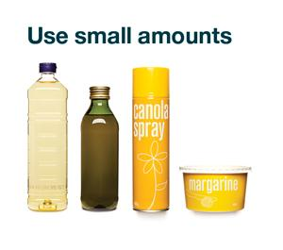

**NUTRIENTS**

Using the information on the last few pages fill in the boxes and match the names of each nutrient to the correct food and function.

|  |  |  |
| --- | --- | --- |
| **Nutrient** | **Foods** | **Function** |
| 1. |  |  |
| 2. |  |  |
| 3. |  |  |
| 4. |  |  |
| 5. |  |  |
| 6. |  |  |
| 7. |  |  |

A study of the food we eat and how it affects our health is called **nutrition**. Our body has to grow, make repairs and maintain good order; and it needs energy to do this. To carry out this massive job we also need to supply our bodies with a number of different **nutrients**. The different nutrients are found in the foods that we eat. Each nutrient has a number of special jobs to carry out.

Most foods are a combination of different nutrients. Some foods contain very small amounts of a nutrient, while others contain very large amounts. It is very important to eat a number of different foods each day so you take in a variety of different nutrients.

The seven nutrients are –

* Carbohydrates – needed for heat and energy, found in sugary and starchy food
* Fats – needed in different amounts by different people for heat and energy, found in butter, oils, cream
* Proteins – needed for growth and repair, found in meat, eggs, fish, soy beans
* Fibre – needed to clean out the bowel, found in grains
* Vitamins – needed for body protection, found in fruit and vegetables
* Minerals – important for blood, teeth and bones, found in dairy products, eggs, fish and meat
* Water – needed for hydration, the main source is water

**WHAT COOKING TERMS DO YOU KNOW?**

**To be able to prepare and cook food, you must be able to understand its language. Match the description with the correct term:**

|  |  |
| --- | --- |
|  | To work or shape a flour mixture by hand |
|  | To remove lumps, add air and mix ingredients |
|  | To mix to a smooth paste or liquid |
|  | To sprinkle a fine substance such as sugar or flour gently on  a surface |
|  | Break into small pieces |
|  | To turn a solid ingredient into a liquid |
|  | To rub food against the surface of a grater |
|  | To cook in bubbling water that has reached 100° |
|  | To cut into even slices, usually across the grain |
|  | To cook food in an oven, surrounded with dry heat |
|  | To aerate cream and eggs to increase volume |
|  | Cooking food by passing an electromagnetic wave through it; heat results from the absorption of energy by the water molecules in the food |
|  | Cooking pasta so that it is tender, but still firm to the bite. |
|  | To cut into small cubes |
|  | To gently blend mixtures together by lifting and turning |
|  | To stir rapidly to make a mixture smooth, using a whisk, spoon, or mixer. |
|  |
|  | To tum the oven on before you start the recipe |
|  | To cook, completely submerged, in hot oil |
|  | To divide into small pieces with a knife or other sharp tool |
|  | To cook food on or under high heat to sear or brown the outside |

|  |  |  |  |  |  |  |
| --- | --- | --- | --- | --- | --- | --- |
| Knead | Melt | Al dente | Grill | Bake | Grate | Microwave |
| Slice | Crumble | Dice | Blend | Fold | Deep-fry | Beat |
| Pre-heat | Dust | Boil | Sift | Chop | Whisk |  |

**THE FOUR C’S OF FOOD SAFETY**

**Clean**

* Wash hands for 20 seconds with warm soapy water and dry them before starting to cook. Repeat after handling raw meats or poultry.
* Wash and dry chopping boards, utensils and work surfaces after preparing raw meats and poultry.

**Cook**

* Cook poultry, hamburger, minced and stuffed meats and sausages until juices run clear.
* Defrost frozen poultry, minced, rolled and stuffed meats thoroughly before cooking.
* Always follow cooking instructions on packaged foods.
* Reheat foods to steaming hot all the way through before eating.
* Cooked foods (including vegetables and rice) should never be reheated more than once.
* Keep hot foods steaming hot at or above 60°C.

**Chill**

* Keep your fridge at 5°C and your freezer at -15°C.
* Keep cooked and perishable foods in the refrigerator.
* Refrigerate hot foods as soon as they stop steaming.
* Refrigerate leftovers promptly.
* Defrost food in the fridge, not on the sink or bench.
* Cook foods defrosted in a microwave immediately.

**Cover**

* Keep raw meat and poultry from touching other food.
* Keep raw meat and poultry in the bottom of the fridge or in a sealed container to prevent drip onto other food.
* Keep food in pantry covered to prevent contamination by chemicals, moulds, bacteria, foreign objects, insects and animals. (Source: Food Bank

**Breakfast**

**“To break the fast”**

Breakfast is the first meal of the day and the most important for many reasons.

Why is it so important? Breakfast…

—Starts your body up

—Replenishes your supply of glucose (energy)

—Provides other essential nutrients (like carbohydrates, protein, fat, vitamins and minerals)

—Keeps your energy levels up throughout the day

—Mood stabilizer

—Boosts concentration

—Satisfies hunger so you don’t binge on junk food

List some factors that influence what you make for breakfast:

|  |  |
| --- | --- |
|  |  |
|  |  |
|  |  |

List 2 healthy and 2 unhealthy breakfast options below. Explain why each is healthy or unhealthy.

|  |  |  |  |  |
| --- | --- | --- | --- | --- |
|  | Food | Reason | Food | Reason |
| Healthy |  |  |  |  |
| Unhealthy |  |  |  |  |

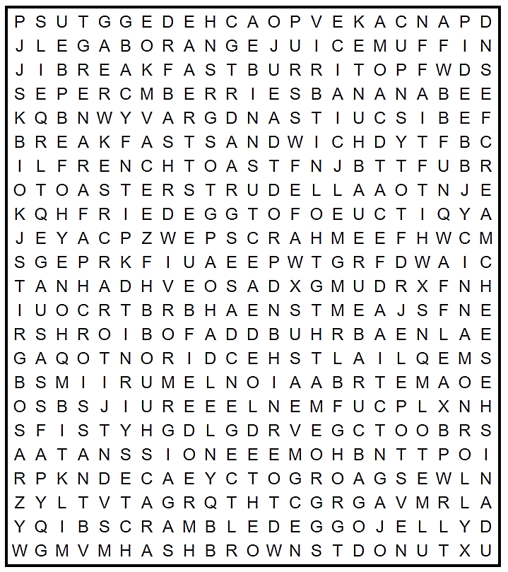**BREAKFAST**

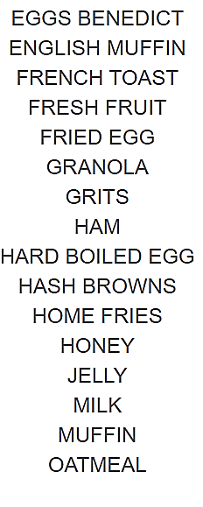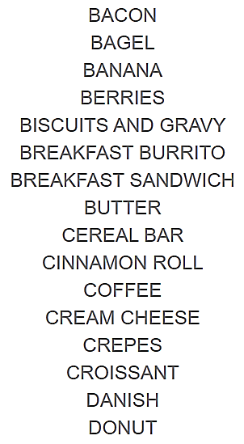

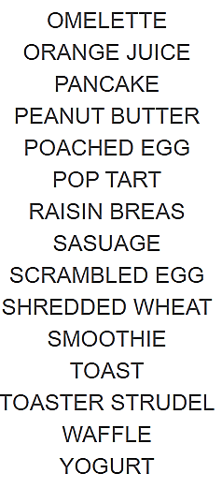

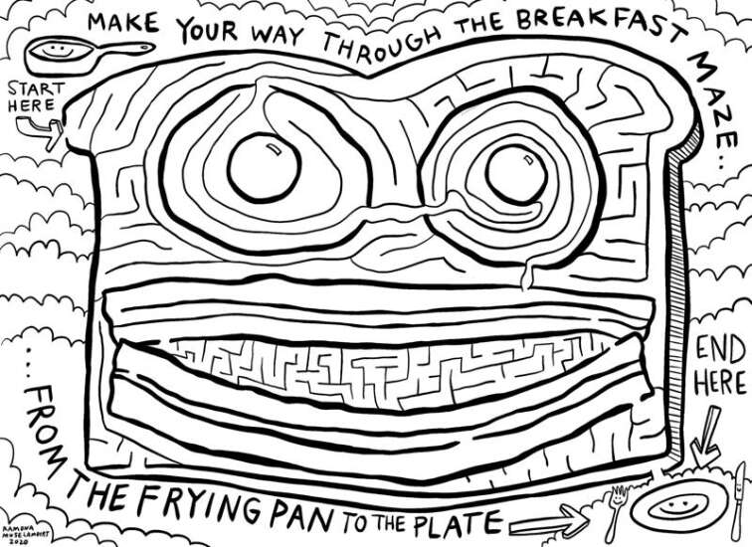

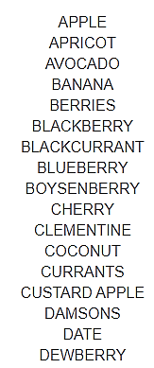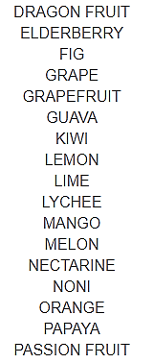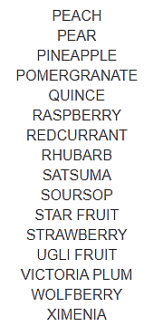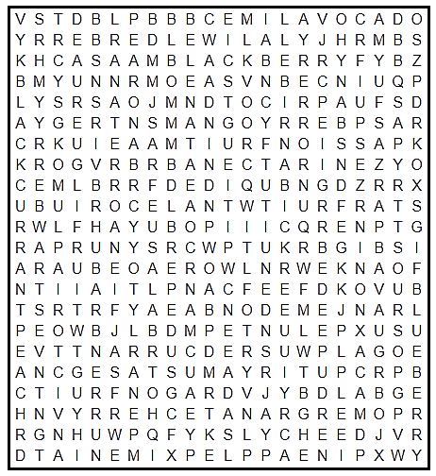**50 FRUITS**

